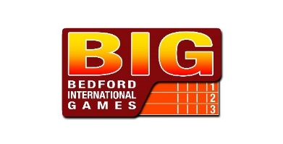
BIGish High Jump 2020
Mini Series 1 (13th / 27th Sept)
OFFICIALS EXPENSES FORM

Thanks again for your help at BIGish High Jump Mini Series. We will be contributing to Officials’ travelling expenses and this year’s rate will be 15p per mile (20p if two or more travelling together). An extra £5 will be added to your expenses in lieu of Food and drink as we are unable to provide this under Covid guidelines. Therefore, could you please complete the slip below and leave it in the box on the Officials Registration Table when you arrive. Cheques will distributed to you later in the day.

ALL Officials need to complete one of these so we can pay the Food money!!! However if you are not claiming for travel can you please delete that section

DATE : 13th September 27th September (please delete)

Name : …………………………………………………………………………………………...

Address: ……………………………………………………………………………………………

£5.00 Food Allowance £ 5 - 00

I travelled by Car: ………………. Miles @ 15p/20p mile £………….

TOTAL £ ………….

The following official(s) travelled with me today:

……………….………..……………………………..

………………………………………………………

Signed………………………………………………………………………

I hasten to add that this can only be a contribution but hope it will, in some small way, convey our appreciation for your continued support.

